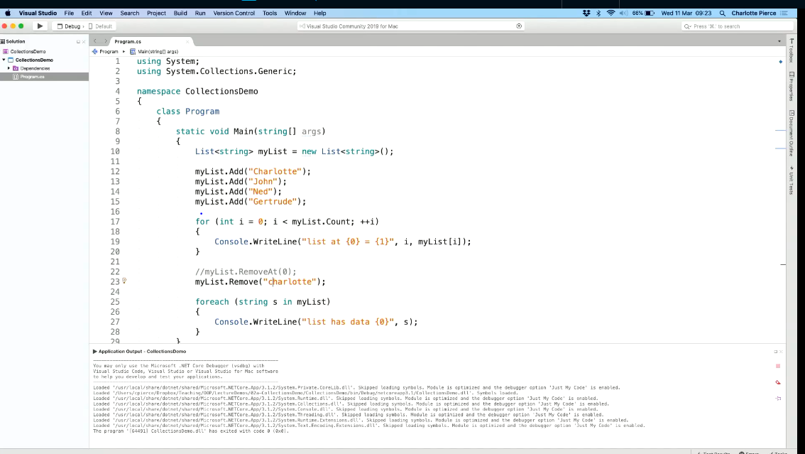

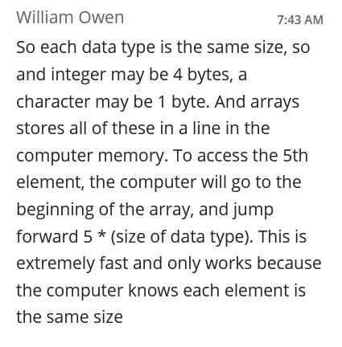

(the reason why we use same data type for array and lists)

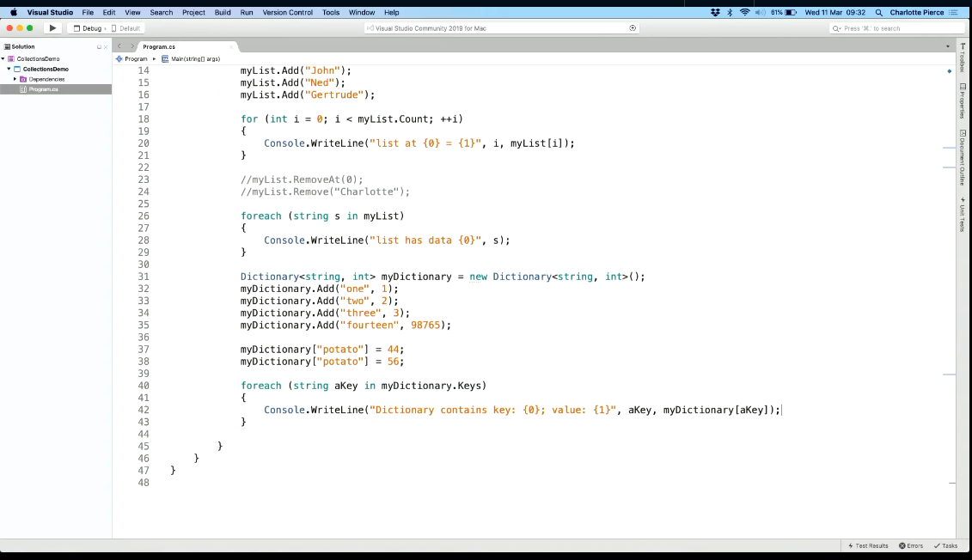

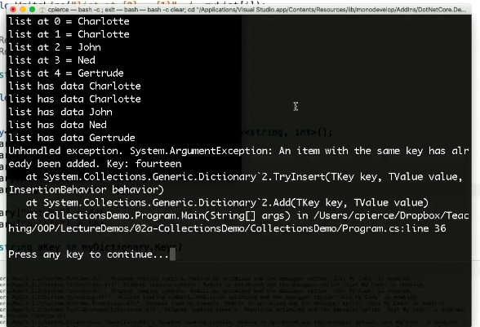

(in case the dictionary had different values for the same key, the upper error message will be displayed)

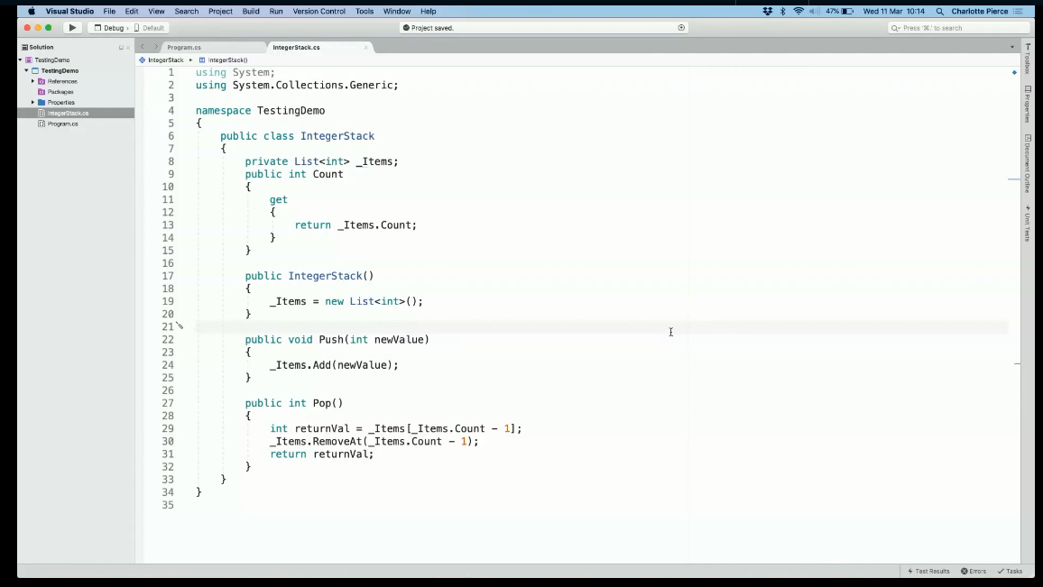

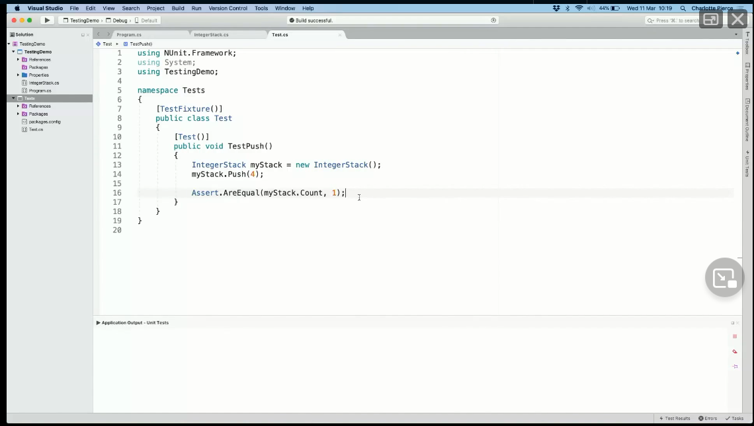

(here we have pushed in only the value “4” in the test. So there is only 1 obj in the “myStack”, then we tested the assert to check total no of obj in the push and see if it is equal to 1 or not)